**Recommender Systems:**

As we can see in youtube or gaana.com, the songs we listen, they will show you next the similar type of songs. Or video you watch you will get similar types of videos to watch next. This all are recommender system.

We can say that if user ui has watched i1, i7, i9 and i9 videos then will he watch ij video too, if yes then we can recommend this to user ui otherwise not.

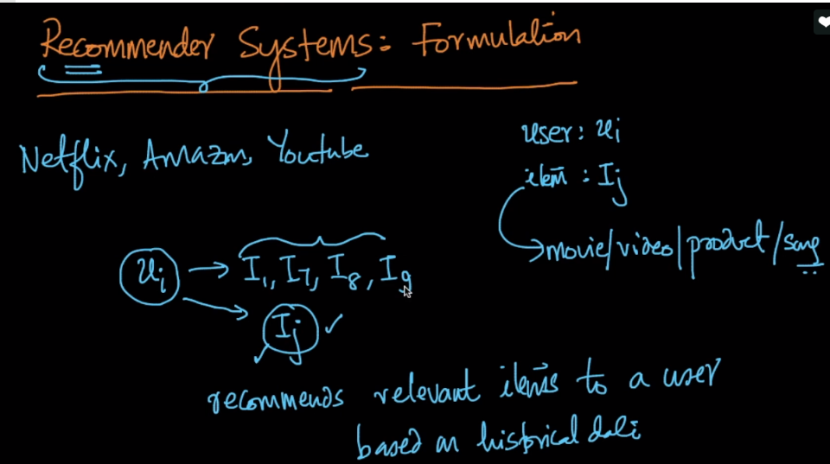

Basically we have a matrix where rows are users and columns are movie, song, product whose value may be rating for product or movie, or Boolean(1 or 0), for songs or video representing whether watched or not.

So let’s say we have 1 million users and 10k movies, so total size of matrix would be 1010.

Now let’s suppose that average user rates 5 movies so filled cells in matrix are 106 * 5, that means there are only this much non empty cells and rest are empty cells, so it’s a sparse matrix.

To know the sparsity of matrix = no. of empty cells / total no. of cells.

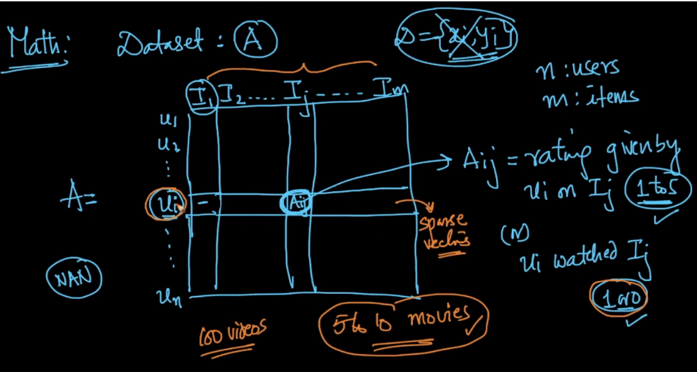

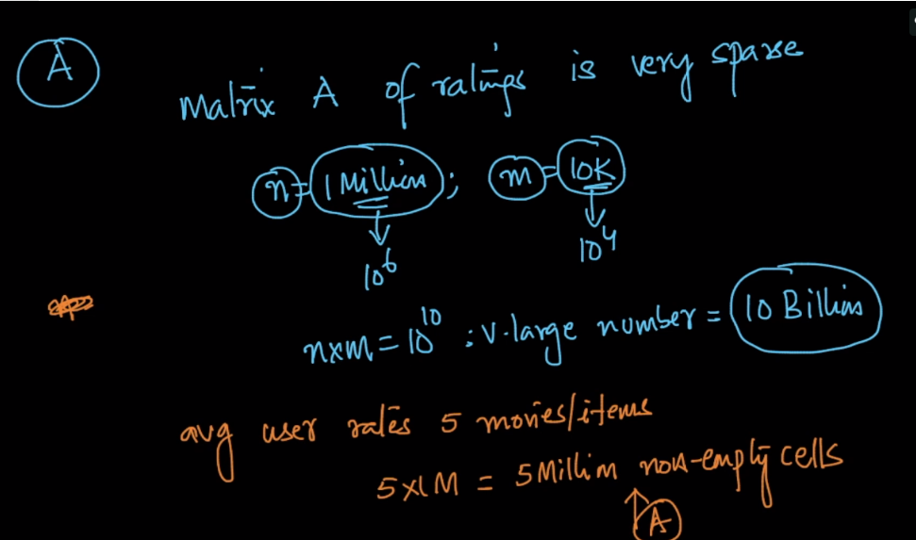



**Objective or Task of Recommender System:**  given user u1 along with items he bought, we need to recommend him new item, which he’s most likely to buy.



We can treat it as a regression or classification problem: regression where rating is given and classification when Boolean values are given.

So basically for training we have training data whose cells are filled, or whose rating are present.

So we need to create features for user ui and product/movie ij and combine with available ratings as output.

We train model using this training data. And test using all the empty cells of the matrix.

Now if a product is predicted high rating of let’s say 4.5 then we would recommend that to user.

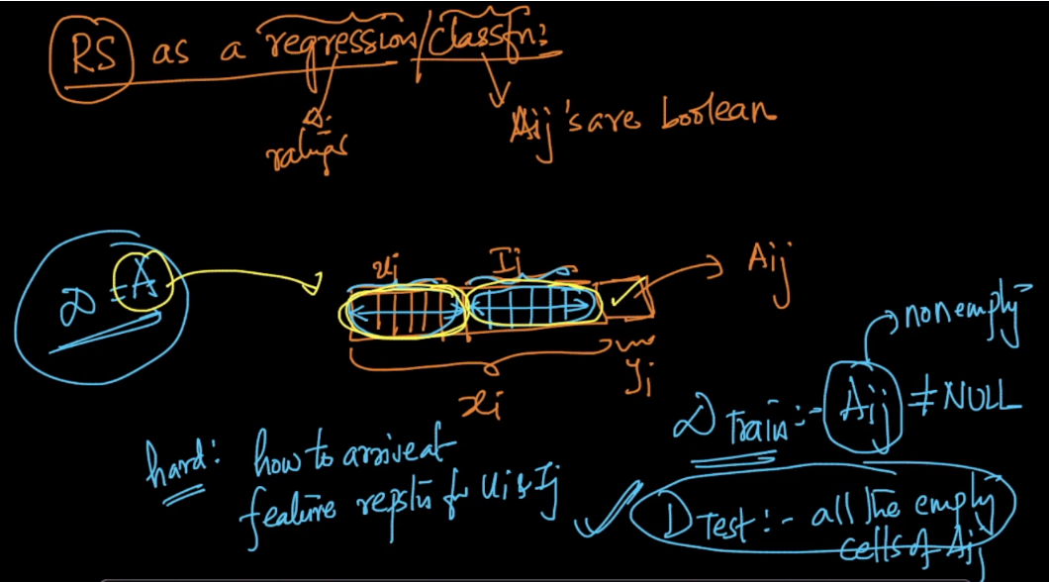

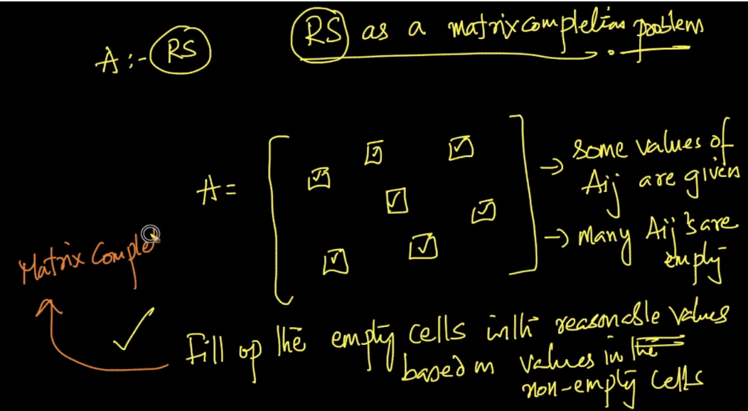

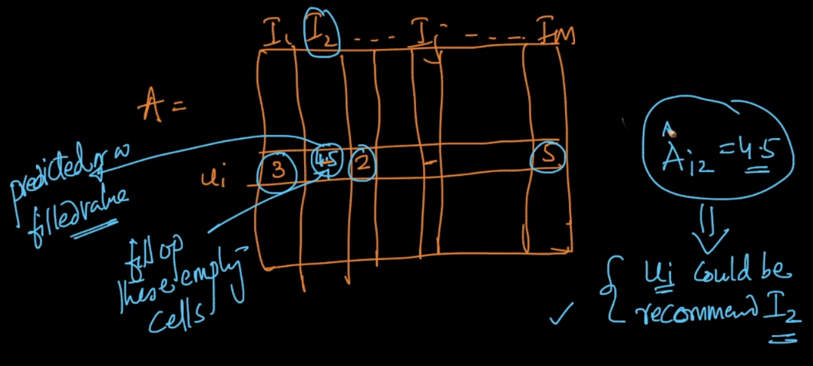

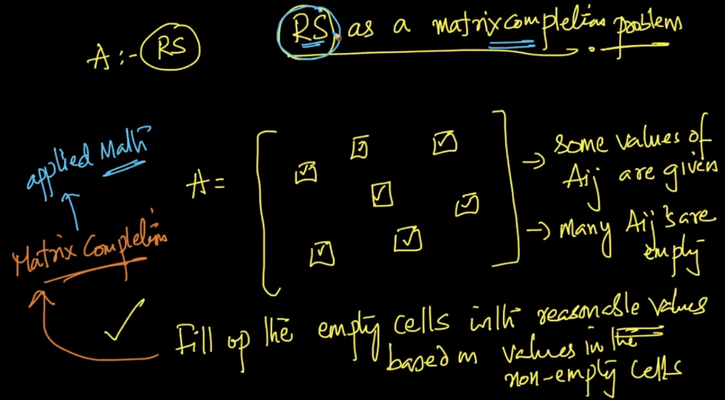

[**Item-Item Collaborative Filtering vs Market Basket Analysis**](https://stats.stackexchange.com/questions/256012/item-item-collaborative-filtering-vs-market-basket-analysis)

